Introduction to Java

Java is a widely used programming language for building web, desktop, mobile, and enterprise applications. It is known for its simple syntax, portability, and powerful features that make development easier and more secure.
- Supports object-oriented programming concepts like classes, objects, inheritance, and polymorphism
- Platform independent because of JVM support
- Secure and robust with strong memory management

History of Java
Java programming language was originally developed by Sun Microsystems which was initiated by James Gosling and released in 1995 as core component of Sun Microsystems' Java platform (Java 1.0 [J2SE]). History of even naming of the Java is very interesting. It went under many names.

Features of Java
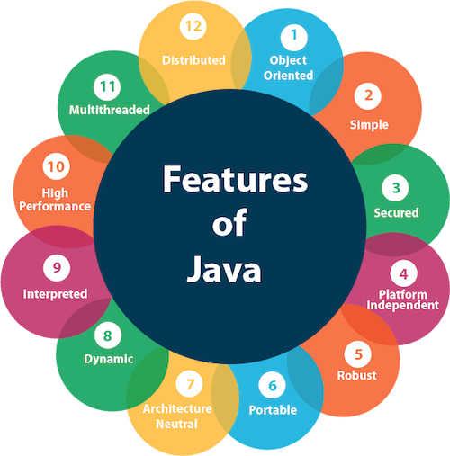

Simple
Java syntax is very straightforward and very easy to learn. Java removes complex features like pointers and multiple inheritance, which makes it a good choice for beginners.

Object-Oriented
Java is a pure object-oriented language. It supports core OOP concepts like,
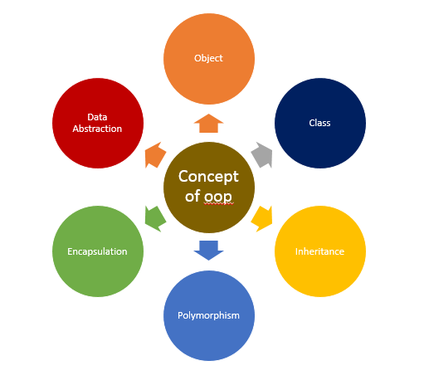

Portable
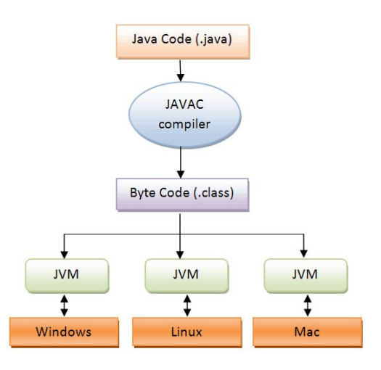

Platform Independent
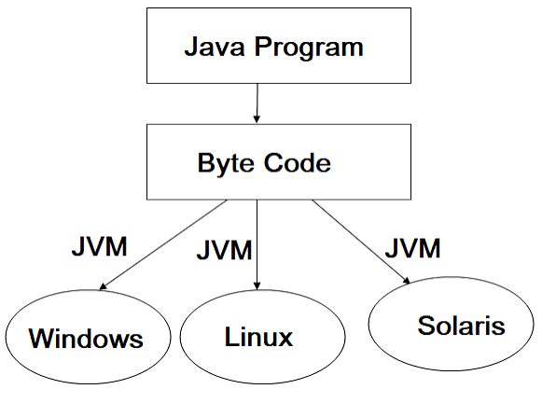

Secured
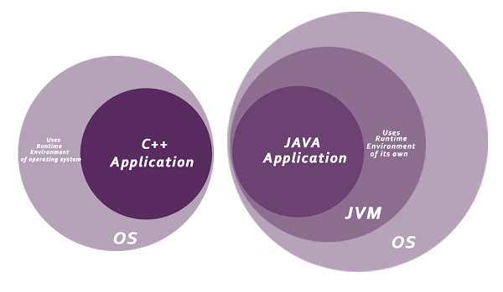
Robust
- It employs strong memory management.
- There is a deficiency of pointers that prevent security issues.
- Java offers automatic garbage collection, which operates on the Java Virtual Machine to dispose of objects that are no longer being utilized by a Java application.
- Java includes exception handling and type checking mechanisms. All these factors contribute to making Java robust.

Architecture Neutral
Unlike many other programming languages including C and C++, when Java is compiled, it is not compiled into platform specific machine , rather into platform-independent byte code. This byte code is distributed over the web and interpreted by the Virtual Machine (JVM) on whichever platform it is being run on.
Thus when you write a piece of Java code in a particular platform and generated an executable code .class file. You can execute/run this .class file on any system the only condition is that the target system should have JVM (JRE) installed in it.

Interpreted
Java's interpreted feature means that Java code is not directly converted into machine code by a compiler. Instead, first, it compiled into bytecode, then executed by the JVM through an interpreter. It allows Java to be platform-independent, meaning the same bytecode can run on any system with a JVM.
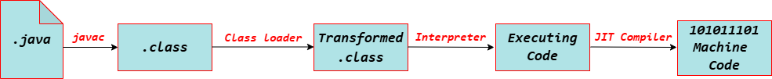

Multithreaded
The main advantage of multi-threading is that it does not occupy memory for each thread but rather shares a common memory area. Threads are crucial for multimedia, web applications, and more.

Distributed

This feature enables access to files by invoking methods from any machine on the Internet.
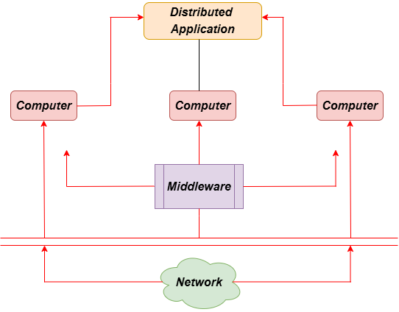
Dynamic
Java is a dynamic language that supports the on-demand loading of classes. It also allows the use of functions from its native languages, namely C and C++.
Java supports dynamic compilation and automatic memory management, including garbage collection.

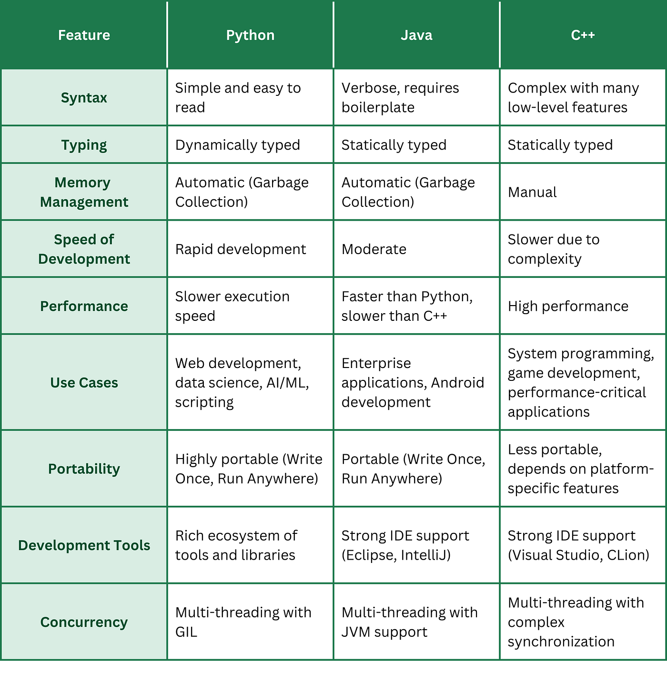

The 3 Core Components of Java
Java is designed to be platform independent, and that’s possible because of its architecture. These three are the building blocks:
- JVM — Java Virtual Machine
- JRE — Java Runtime Environment
- JDK — Java Development Kit

JVM - Java Virtual Machine
JVM is the engine that runs your Java program.
- JVM is an abstract machine — it doesn’t exist physically.
- It reads the bytecode generated by the Java compiler and converts it into machine code for the OS (Windows, macOS, Linux).
- That’s why the JVM is platform dependent, but the bytecode it runs is platform independent.

JRE - Java Runtime Environment
JRE = JVM + Class Libraries
- It includes the JVM
- It also includes core libraries like java.util, java.io, etc.
So if you just want to run a Java program (not write or compile it), JRE is enough.

JDK - Java Development Kit
JDK = JRE + Development Tools (compiler, debugger, etc.)
- If you’re a Java developer, you need JDK to write, compile, and run programs.

It includes:
- Java compiler (javac)
- Java debugger
- JAR tool
- Documentation generator
- And much more

Aspect | JDK | JRE | JVM
Purpose | Used to develop Java applications | Used to run Java applications | Executes Java bytecode
Platform Dependency | Platform-dependent (OS specific) | Platform-dependent (OS specific) | JVM is OS-specific, but bytecode is platform-independent
Includes | JRE + Development tools (javac, debugger, etc.) | JVM + Libraries (e.g., rt.jar) | ClassLoader, JIT Compiler, Garbage Collector
Use Case | Writing and compiling Java code | Running a Java application on a system | Convert bytecode into native machine code

Installation

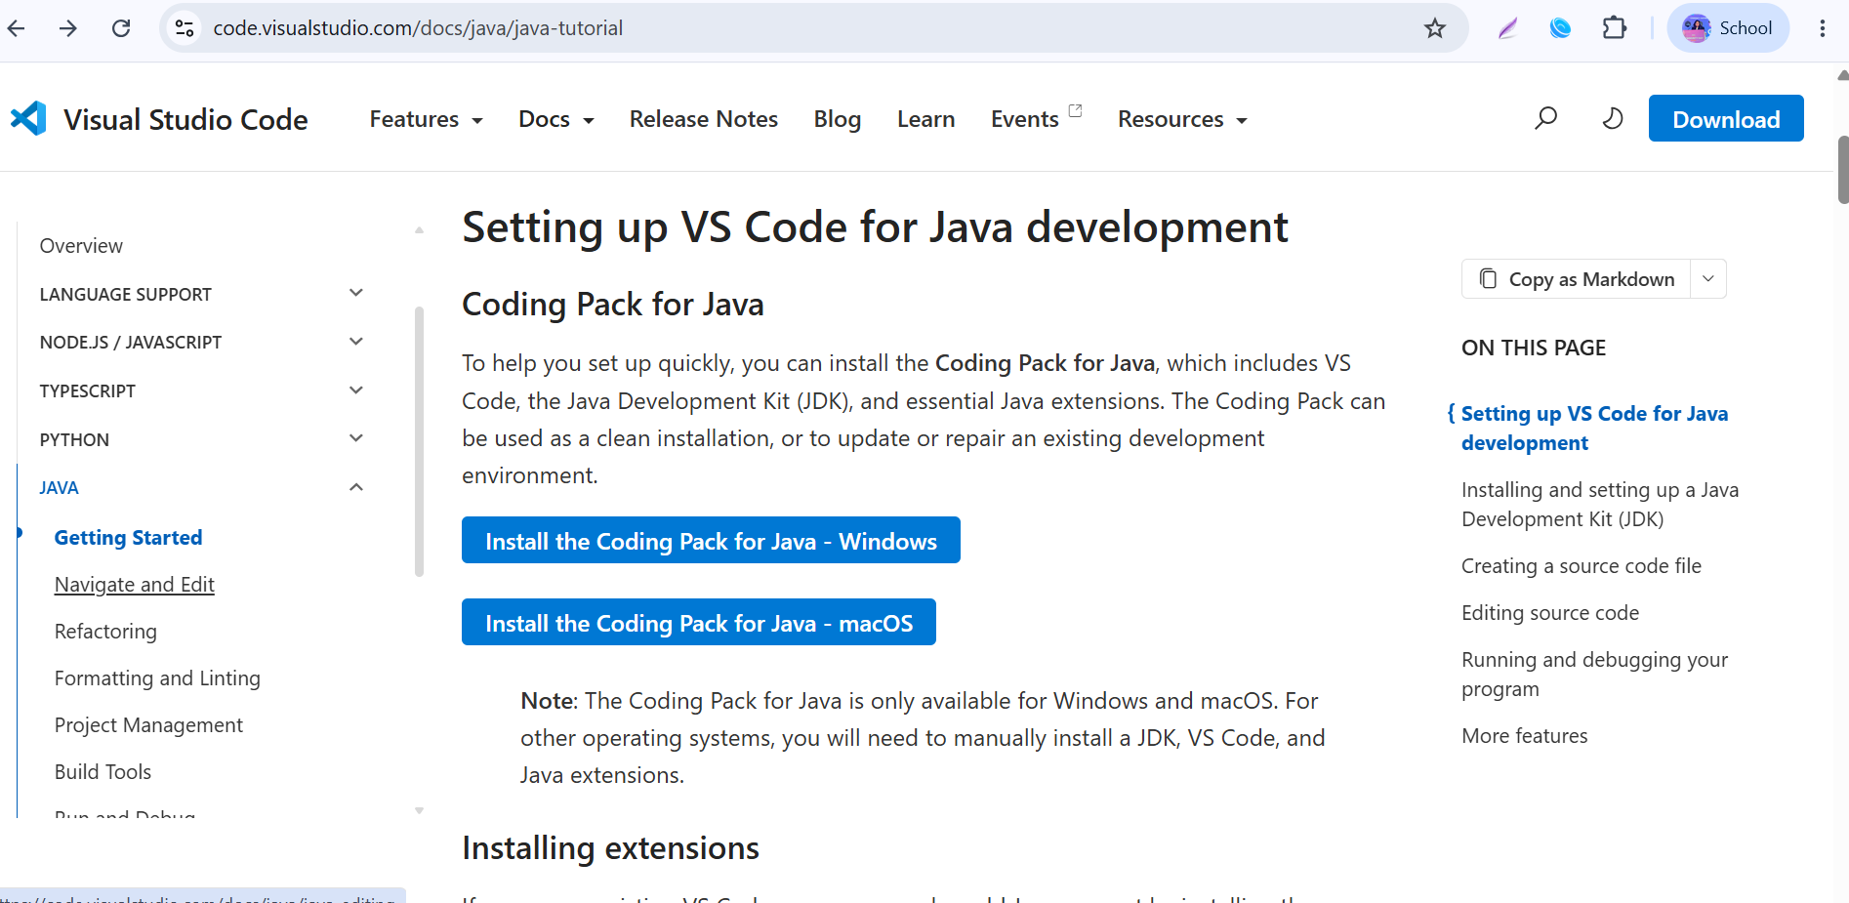

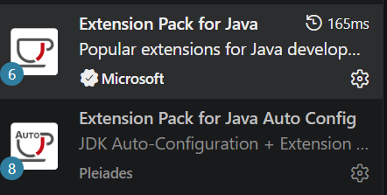

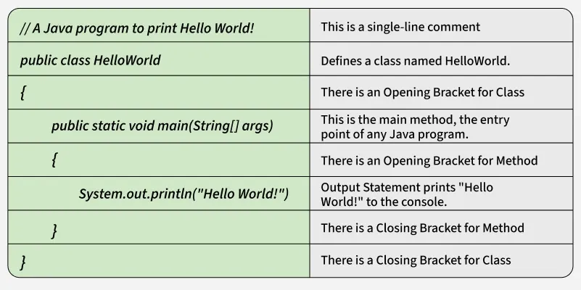

Variables, Data Types and Literals

1. Variables
A variable is a named memory location used to store data. The value stored in a variable can be changed during program execution.
Syntax
dataType variableName = value;

Example
int age = 20;

Here,
- int → Data Type
- age → Variable Name
- 20 → Value

Program: Using Variables
public class Variable
{
public static void main(String[] args)
{
int age = 36;
String name = "Arun";

System.out.println("Name : " + name);
System.out.println("Age : " + age);

}
}

Output
Name : Arun
Age : 36

2. Declaration and Initialization
Before using a variable, it must be declared.
Declaration
int marks;

Initialization
marks = 90;

Declaration + Initialization
int marks = 90;

Program:
public class DeclarationDemo {
public static void main(String[] args) {

int marks;
marks = 90;

System.out.println("Marks = " + marks);

}
}

Output
Marks = 90

3. Data Types
A data type tells Java what kind of value can be stored in a variable.

Primitive Data Types
Data Type | Example
int | 100
double | 85.75
char | 'A'
boolean | true

Program
public class DataTypes {
public static void main(String[] args) {

int rollNo = 101;
double percentage = 87.50;
char grade = 'A';
boolean result = true;

System.out.println("Roll No : " + rollNo);
System.out.println("Percentage : " + percentage);
System.out.println("Grade : " + grade);
System.out.println("Result : " + result);

}
}

Output
Roll No : 101
Percentage : 89.5
Grade : A
Result : true

4. Non-Primitive Data Type (String)
A String stores multiple characters (text).
Example
String city = "Pune";

Program
public class StringDemo {
public static void main(String[] args) {

String name = "Rahul";
String city = "Pune";

System.out.println(name);
System.out.println(city);

}
}

Output:
Rahul
Pune

5. Literals
A literal is a fixed value written directly in the program.
Examples
int age = 20;
double pi = 3.14;
char grade = 'A';
String name = "Java";
boolean passed = true;

Program
public class Literal {
public static void main(String[] args) {

int number = 50;
double price = 99.99;
char grade = 'B';
String course = "Java";
boolean completed = true;

System.out.println(number);
System.out.println(price);
System.out.println(grade);
System.out.println(course);
System.out.println(completed);

}
}

6. Variable Naming Rules
Valid:
studentName
rollNo
salary
_marks

Invalid:
1marks
student name
class
roll-no

Program
public class Naming {
public static void main(String[] args) {

int studentAge = 19;
double examScore = 92.5;

System.out.println(studentAge);
System.out.println(examScore);

}
}

7. Type Compatibility
A variable can store only the value that matches its data type.
Correct
int age = 20;

Incorrect
int age = 20.5;

Reason: Decimal values cannot be stored in an int.

Program
public class Compatibility
{
public static void main(String[ ] args)
{
double height = 5.9;
int age = 21;
System.out.println(height);
System.out.println(age);

}
}

Program 1: Display Personal Information
Aim:
Write a Java program to display your personal information such as Name, Age, Qualification, City, and Mobile Number.
Objective:
To understand the basic structure of a Java program and the use of the System.out.println() method for displaying output.

Program 2: Perform Arithmetic Operations on Two Numbers
Aim:
Write a Java program to perform arithmetic operations (Addition, Subtraction, Multiplication, Division, and Modulus) on two numbers entered by the user.
Objective:
To understand the use of variables, arithmetic operators, and user input using the Scanner class.

Program 3: Calculate the Percentage of Five Subjects
Aim:
Write a Java program to calculate the total marks and percentage of a student by accepting marks in five subjects.
Objective:
To understand the use of variables, arithmetic expressions, and basic mathematical calculations in Java.

